- Description
IPS020*E is the IC for differential output SPXO whose Phase Noise is quite low. This IC suites for telecommunication applications. This IC also supports pCML (Pseudo CML) output.
We also offer models with the best pad layout for flip chip bonding.

- Features
- Operation temperature : -40℃~125℃
- Power supply voltage : 2.375V~3.63V (LVDS & HCSL)
2.375V~2.625V (2.5V LVPECL)
2.97V~3.63V (3.3V LVPECL & pCML)
- Standby function : Oscillation stop
- Crystal frequency : 220MHz maximum
- Output : LVPECL / LVDS / HCSL / Pseudo CML (HDLVDS : High Drive LVDS)
- Crystal mode : Fundamental & 3rd overtone
- Small chip size : 0.65mm × 0.75mm
- Pad layout : Straight type & Flip type
- Duty cycle : Within 50%±5%
- Phase jitter : ~57fsec (12kHz to 20MHz at 156.25MHz)

- Part number rule

The contents of this sheet are subject to change without notice.

- Series
Part Number |  |  |  |  |  |  |  | Output | Crystal Frequency  (MHz) |  |  | Divide | Output  Frequency  (MHz) |  | Remarks
 |  |  |  |  |  |  |  | Output | Mode | Min. | Max. | Divide | Min. | Max. | Remarks
IPS020 | 3 | M | 0 | P |  | E | S | LVPECL  (V_{DD}=  3.3V  ±10%) | Fund. | 27 | 100 | 1/1 | 27 | 100 | Straight type
IPS020 | 4 | M | 0 | P |  | E | S | LVPECL  (V_{DD}=  3.3V  ±10%) | Fund. | 80 | 130 | 1/1 | 80 | 130 | Straight type
IPS020 | 5 | M | 0 | P |  | E | S | LVPECL  (V_{DD}=  3.3V  ±10%) | Fund. | 120 | 170 | 1/1 | 120 | 170 | Straight type
IPS020 | 6 | M | 0 | P |  | E | S | LVPECL  (V_{DD}=  3.3V  ±10%) | Fund. | 160 | 220 | 1/1 | 160 | 220 | Straight type
IPS020 | 3 | M | 1 | P |  | E | S | LVPECL  (V_{DD}=  3.3V  ±10%) | Fund. | 27 | 100 | 1/2 | 13.5 | 50 | Straight type
IPS020 | 3 | M | T | P |  | E | S | LVPECL  (V_{DD}=  3.3V  ±10%) | 3rd | 65 | 90 | 1/1 | 65 | 90 | Straight type
IPS020 | 4 | M | T | P |  | E | S | LVPECL  (V_{DD}=  3.3V  ±10%) | 3rd | 90 | 125 | 1/1 | 90 | 125 | Straight type
IPS020 | 5 | M | T | P |  | E | S | LVPECL  (V_{DD}=  3.3V  ±10%) | 3rd | 125 | 160 | 1/1 | 125 | 160 | Straight type
IPS020 | 6 | M | T | P |  | E | S | LVPECL  (V_{DD}=  3.3V  ±10%) | 3rd | 160 | 220 | 1/1 | 160 | 220 | Straight type
IPS020 | 4 | M | 0 | P |  | E | F | LVPECL  (V_{DD}=  3.3V  ±10%) | Fund. | 50 | 150 | 1/1 | 50 | 150 | Flip type
IPS020 | 5 | M | 0 | P |  | E | F | LVPECL  (V_{DD}=  3.3V  ±10%) | Fund. | 100 | 200 | 1/1 | 100 | 200 | Flip type
IPS020 | 3 | M | 0 | P | A | E | S | LVPECL  (V_{DD}=  2.5V  ±5%) | Fund. | 27 | 100 | 1/1 | 27 | 100 | Straight type
IPS020 | 4 | M | 0 | P | A | E | S | LVPECL  (V_{DD}=  2.5V  ±5%) | Fund. | 80 | 130 | 1/1 | 80 | 130 | Straight type
IPS020 | 5 | M | 0 | P | A | E | S | LVPECL  (V_{DD}=  2.5V  ±5%) | Fund. | 120 | 170 | 1/1 | 120 | 170 | Straight type
IPS020 | 6 | M | 0 | P | A | E | S | LVPECL  (V_{DD}=  2.5V  ±5%) | Fund. | 160 | 220 | 1/1 | 160 | 220 | Straight type
IPS020 | 3 | M | 1 | P | A | E | S | LVPECL  (V_{DD}=  2.5V  ±5%) | Fund. | 27 | 100 | 1/2 | 13.5 | 50 | Straight type
IPS020 | 3 | M | T | P | A | E | S | LVPECL  (V_{DD}=  2.5V  ±5%) | 3rd | 65 | 90 | 1/1 | 65 | 90 | Straight type
IPS020 | 4 | M | T | P | A | E | S | LVPECL  (V_{DD}=  2.5V  ±5%) | 3rd | 90 | 125 | 1/1 | 90 | 125 | Straight type
IPS020 | 5 | M | T | P | A | E | S | LVPECL  (V_{DD}=  2.5V  ±5%) | 3rd | 125 | 160 | 1/1 | 125 | 160 | Straight type
IPS020 | 6 | M | T | P | A | E | S | LVPECL  (V_{DD}=  2.5V  ±5%) | 3rd | 160 | 220 | 1/1 | 160 | 220 | Straight type
IPS020 | 4 | M | 0 | P | A | E | F | LVPECL  (V_{DD}=  2.5V  ±5%) | Fund. | 50 | 150 | 1/1 | 50 | 150 | Flip type
IPS020 | 5 | M | 0 | P | A | E | F | LVPECL  (V_{DD}=  2.5V  ±5%) | Fund. | 100 | 200 | 1/1 | 100 | 200 | Flip type
IPS020 | 3 | M | 0 | D |  | E | S | LVDS | Fund. | 27 | 100 | 1/1 | 27 | 100 | Straight type
IPS020 | 4 | M | 0 | D |  | E | S | LVDS | Fund. | 80 | 130 | 1/1 | 80 | 130 | Straight type
IPS020 | 5 | M | 0 | D |  | E | S | LVDS | Fund. | 120 | 170 | 1/1 | 120 | 170 | Straight type
IPS020 | 6 | M | 0 | D |  | E | S | LVDS | Fund. | 160 | 220 | 1/1 | 160 | 220 | Straight type
IPS020 | 3 | M | 1 | D |  | E | S | LVDS | Fund. | 27 | 100 | 1/2 | 13.5 | 50 | Straight type
IPS020 | 3 | M | T | D |  | E | S | LVDS | 3rd | 65 | 90 | 1/1 | 65 | 90 | Straight type
IPS020 | 4 | M | T | D |  | E | S | LVDS | 3rd | 90 | 125 | 1/1 | 90 | 125 | Straight type
IPS020 | 5 | M | T | D |  | E | S | LVDS | 3rd | 125 | 160 | 1/1 | 125 | 160 | Straight type
IPS020 | 6 | M | T | D |  | E | S | LVDS | 3rd | 160 | 220 | 1/1 | 160 | 220 | Straight type
IPS020 | 4 | M | 0 | D |  | E | F | LVDS | Fund. | 50 | 150 | 1/1 | 50 | 150 | Flip type
IPS020 | 5 | M | 0 | D |  | E | F | LVDS | Fund. | 100 | 200 | 1/1 | 100 | 200 | Flip type

Part Number |  |  |  |  |  |  |  | Output | Crystal Frequency  (MHz) |  |  | Divide | Output  Frequency  (MHz) |  | Remarks
 |  |  |  |  |  |  |  | Output | Mode | Min. | Max. | Divide | Min. | Max. | Remarks
IPS020 | 3 | M | 0 | H |  | E | S | HCSL | Fund. | 27 | 100 | 1/1 | 27 | 100 | Straight type
IPS020 | 4 | M | 0 | H |  | E | S | HCSL | Fund. | 80 | 130 | 1/1 | 80 | 130 | Straight type
IPS020 | 5 | M | 0 | H |  | E | S | HCSL | Fund. | 120 | 170 | 1/1 | 120 | 170 | Straight type
IPS020 | 6 | M | 0 | H |  | E | S | HCSL | Fund. | 160 | 220 | 1/1 | 160 | 220 | Straight type
IPS020 | 3 | M | 1 | H |  | E | S | HCSL | Fund. | 27 | 100 | 1/2 | 13.5 | 50 | Straight type
IPS020 | 3 | M | T | H |  | E | S | HCSL | 3rd | 65 | 90 | 1/1 | 65 | 90 | Straight type
IPS020 | 4 | M | T | H |  | E | S | HCSL | 3rd | 90 | 125 | 1/1 | 90 | 125 | Straight type
IPS020 | 5 | M | T | H |  | E | S | HCSL | 3rd | 125 | 160 | 1/1 | 125 | 160 | Straight type
IPS020 | 6 | M | T | H |  | E | S | HCSL | 3rd | 160 | 220 | 1/1 | 160 | 220 | Straight type
IPS020 | 4 | M | 0 | H |  | E | F | HCSL | Fund. | 80 | 130 | 1/1 | 80 | 130 | Flip type
IPS020 | 5 | M | 0 | H |  | E | F | HCSL | Fund. | 120 | 170 | 1/1 | 120 | 170 | Flip type
IPS020 | 5 | M | 0 | C |  | E | F | pCML | Fund. | 100 | 200 | 1/1 | 100 | 200 | Flip type
IPS020 | 4 | M | T | C |  | E | S | pCML | 3rd | 90 | 125 | 1/1 | 90 | 125 | Straight type
IPS020 | 5 | M | T | C |  | E | S | pCML | 3rd | 125 | 160 | 1/1 | 125 | 160 | Straight type

- Absolute Maximum Ratings
V_{SS}=0V, Ta=25℃± 2℃
Parameter | Symbol | Condition | Ratings
Parameter | Symbol | Condition | Min | Max | Unit
Supply Voltage | V_{DD} |  | V_{SS}-0.5 | 5.0 | V
Input Voltage | V_{IN} | All Input Pin | V_{SS}-0.5 | V_{DD}+0.5 | V
Output Voltage | V_{OUT} |  | V_{SS}-0.5 | V_{DD}+0.5 | V
Output Current | I_{OUT} |  |  | 25 | mA
Junction Temperature | Tj |  | -55 | 150 | ℃
Storage Temperature | Tstg |  | -55 | 125 | ℃

- Recommended Operating Condition
V_{SS}=0V, Ta=-40℃~125℃
Parameter | Symbol | Condition | Min | Typ | Max | Unit | Note
Supply Voltage | V_{DD} | 2.5V LVPECL | 2.375 | 2.50 | 2.625 | V | V_{DD}
Supply Voltage | V_{DD} | LVDS, HCSL | 2.375 | 3.30 | 3.63 | V | V_{DD}
Supply Voltage | V_{DD} | 3.3V LVPECL, pCML | 2.97 | 3.30 | 3.63 | V | V_{DD}
“H” Input Voltage | V_{IH} |  | V_{DD}×0.7 |  |  | V | CE
“L” Input Voltage | V_{IL} |  |  |  | V_{DD}×0.3 | V | CE
Input Voltage | V_{IN} |  | V_{SS} |  | V_{DD} | V | CE
Output Load Resistance | RL | LVPECL ※1 | 49.5 | 50.0 | 50.5 | Ω | OUT
Output Load Resistance | RL | LVDS ※2 | 99 | 100 | 101 | Ω | OUT
Output Load Resistance | RL | HCSL ※3 | 49.5 | 50.0 | 50.5 | Ω | OUT
Output Load Resistance | RL | pCML ※4 | 80 | 100 | 120 | Ω | OUT
Ambient Temperature | Topt |  | -40 |  | 125 | ℃
This IC has enough immunity against ESD and Latch-up, but handle with care.

※1 Terminate to V_{DD}-2.0V
※2 Between OUT and OUTN
※3 To GND and Rs=33Ω or 0Ω
※4 Refer to Fig.4-1

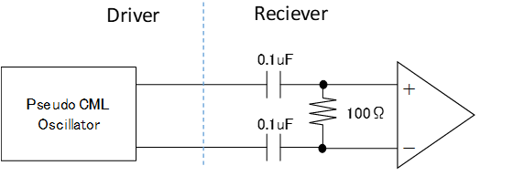

Fig. 4-1 pCML RL condition

- Electrical Specification
5-1 LVPECL Output (V_{DD}=3.3V Operation)
5-1-1 DC Characteristics
Unless otherwise stated, V_{DD}=2.97V~3.63V, V_{SS}=0V, Ta=-40℃~125℃
Parameter | Symbol | Condition |  | Specification |  |  | Unit
Parameter | Symbol |  |  | Min | Typ | Max | Unit
Output leak current | I_{Z} | CE=0.3V |  |  |  | 10 | μA
“L” input current | I_{IL} | V_{IN}=V_{SS} |  |  | -10 |  | μA
“H” output voltage | V_{OH} | RL=50Ω(Terminated to V_{DD}-2.0V)  CE=Open, OUT/OUTN |  | V_{DD}  -1.025 | V_{DD}  -0.950 | V_{DD}  -0.880 | V
“L” output voltage | V_{OL} |  |  | V_{DD}  -1.810 | V_{DD}  -1.700 | V_{DD}  -1.620 | V
Current consumption※ | I_{DD} | IPS0203M0PES, F0=100MHz |  |  | 34.0 | 51.0 | mA
Current consumption※ | I_{DD} | IPS0204M0PEq, F0=122.88MHz |  |  | 36.0 | 54.0 | mA
Current consumption※ | I_{DD} | IPS0205M0PEq, F0=170MHz |  |  | 38.0 | 57.0 | mA
Current consumption※ | I_{DD} | IPS0206M0PES, F0=212.5MHz |  |  | 38.0 | 57.0 | mA
Current consumption※ | I_{DD} | IPS0203MTPES, F0=90MHz |  |  | 35.0 | 52.0 | mA
Current consumption※ | I_{DD} | IPS0204MTPES, F0=125MHz |  |  | 37.0 | 55.0 | mA
Current consumption※ | I_{DD} | IPS0205MTPES, F0=156.25MHz |  |  | 38.0 | 57.0 | mA
Current consumption※ | I_{DD} | IPS0206MTPES, F0=200MHz |  |  | 40.0 | 60.0 | mA
Current consumption at oscillation stop | I_{DDD} | CE=GND | Straight type |  |  | 10 | uA
Current consumption at oscillation stop | I_{DDD} | CE=GND | Flip type |  | 60 | 300 | uA
※Condition : V_{DD}=3.3V, CE=Open, RL=50Ω (Terminated to V_{DD}-2.0V)

5-1-2 Switching Characteristics
Unless otherwise stated, V_{DD}=2.97V~3.63V, V_{SS}=0V, Ta=-40℃~125℃
Parameter | Symbol | Condition |  | Specification |  |  | Unit
Parameter | Symbol |  |  | Min | Typ | Max | Unit
Oscillation start up time | Tstart | IPS020xM0 |  |  |  | 2.0 | ms
Oscillation start up time | Tstart | IPS020xMT |  |  |  | 10.0 | ms
Output Disable Time | Tplz |  |  |  |  | 200 | ns
Output Enable Time | Tpzl | IPS020xM0 |  |  |  | 2.0 | ms
Output Enable Time | Tpzl | IPS020xMT |  |  |  | 10.0 | ms
Rise time / Fall time | Tr / Tf | 20%~80% Vopp |  |  | 0.25 | 0.40 | ns
Output Duty Ratio | Duty | 1/2Vopp point |  | 45 |  | 55 | %
Output Duty Ratio | Duty | Only IPS0206MT  1/2Vopp point | Ta=-40℃~85℃ | 45 |  | 55 | %
Output Duty Ratio | Duty | Only IPS0206MT  1/2Vopp point | Ta=85℃~125℃ | 40 |  | 60 | %
Output Swing | Vopp |  |  | 0.4 |  |  | V
Freq. V_{DD} deviation | Fvst | V_{DD}=3.3V±10% |  |  |  | ±2.0 | ppm

5-2 LVPECL Output (V_{DD}=2.5V Operation)
5-2-1 DC Characteristics
Unless otherwise stated, V_{DD}=2.375V~2.625V, V_{SS}=0V, Ta=-40℃~125℃
Parameter | Symbol | Condition |  | Specification |  |  | Unit
Parameter | Symbol |  |  | Min | Typ | Max | Unit
Output leak current | I_{Z} | CE=0.3V |  |  |  | 10 | μA
“L” input current | I_{IL} | V_{IN}=V_{SS} |  |  | -10 |  | μA
“H” output voltage | V_{OH} | RL=50Ω(Terminated to V_{DD}-2.0V)  CE=Open, OUT/OUTN |  | V_{DD}  -1.105 | V_{DD}  -0.950 | V_{DD}  -0.880 | V
“L” output voltage | V_{OL} |  |  | V_{DD}  -1.810 | V_{DD}  -1.700 | V_{DD}  -1.620 | V
Current consumption※ | I_{DD} | IPS0203M0PAES, F0=100MHz |  |  | 31 | 46 | mA
Current consumption※ | I_{DD} | IPS0204M0PAEq, F0=122.88MHz |  |  | 33 | 50 | mA
Current consumption※ | I_{DD} | IPS0205M0PAEq, F0=170MHz |  |  | 33 | 50 | mA
Current consumption※ | I_{DD} | IPS0206M0PAES, F0=212.5MHz |  |  | 33 | 50 | mA
Current consumption※ | I_{DD} | IPS0203MTPAES, F0=90MHz |  |  | 32 | 48 | mA
Current consumption※ | I_{DD} | IPS0204MTPAES, F0=125MHz |  |  | 34 | 51 | mA
Current consumption※ | I_{DD} | IPS0205MTPAES, F0=156.25MHz |  |  | 35 | 53 | mA
Current consumption※ | I_{DD} | IPS0206MTPAES, F0=200MHz |  |  | 37 | 56 | mA
Current consumption at oscillation stop | I_{DDD} | CE=GND | Straight type |  |  | 10 | uA
Current consumption at oscillation stop | I_{DDD} | CE=GND | Flip type |  | 60 | 300 | uA
※Condition : V_{DD}=2.5V, CE=Open, RL=50Ω (Terminated to V_{DD}-2.0V)

5-2-2 Switching Characteristics
Unless otherwise stated, V_{DD}=2.375V~2.625V, V_{SS}=0V, Ta=-40℃~125℃
Parameter | Symbol | Condition |  | Specification |  |  | Unit
Parameter | Symbol |  |  | Min | Typ | Max | Unit
Oscillation start up time | Tstart | IPS020xM0 |  |  |  | 2.0 | ms
Oscillation start up time | Tstart | IPS020xMT |  |  |  | 10 | ms
Output Disable Time | Tplz |  |  |  |  | 200 | ns
Output Enable Time | Tpzl | IPS020xM0 |  |  |  | 2.0 | ms
Output Enable Time | Tpzl | IPS020xMT |  |  |  | 10 | ms
Rise time / Fall time | Tr / Tf | 20%~80% Vopp |  |  | 0.25 | 0.40 | ns
Output Duty Ratio | Duty | 1/2Vopp point |  | 45 |  | 55 | %
Output Duty Ratio | Duty | Only IPS0206MT  1/2Vopp point | Ta=-40℃~85℃ | 45 |  | 55 | %
Output Duty Ratio | Duty | Only IPS0206MT  1/2Vopp point | Ta=85℃~125℃ | 40 |  | 60 | %
Output Swing | Vopp |  |  | 0.4 |  |  | V
Freq. V_{DD} deviation | Fvst | V_{DD}=2.5V±5% |  |  |  | ±2.0 | ppm

5-3 LVDS Output
5-3-1 DC Characteristics
Unless otherwise stated, V_{DD}=2.375V~3.63V, V_{SS}=0V, Ta=-40℃~125℃
Parameter | Symbol | Condition |  | Specification |  |  | Unit
Parameter | Symbol |  |  | Min | Typ | Max | Unit
Output leak current | I_{Z} | CE=0.3V |  |  |  | 10 | μA
“L” input current | I_{IL} | V_{IN}=V_{SS} |  |  | -10 |  | μA
“H” output voltage | V_{OH} | RL=100Ω(Between OUT & OUTN)  CE=Open, OUT/OUTN |  |  | 1.43 | 1.60 | V
“L” output voltage | V_{OL} |  |  | 0.90 | 1.10 |  | V
Differential voltage | V_{OD} |  |  | 247 | 330 | 454 | mV
Differential voltage  deviation | ⊿V_{OD} |  |  |  |  | 50 | mV
Offset voltage | V_{OS} |  |  | 1.125 | 1.250 | 1.375 | V
Offset voltage  deviation | ⊿V_{OS} |  |  |  |  | 50 | mV
Current consumption※ | I_{DD} | IPS0203M0DES, F0=100MHz |  |  | 8.5 | 17.0 | mA
Current consumption※ | I_{DD} | IPS0204M0DES, F0=122.88MHz |  |  | 10.5 | 21.0 | mA
Current consumption※ | I_{DD} | IPS0205M0DES, F0=170MHz |  |  | 12.5 | 25.0 | mA
Current consumption※ | I_{DD} | IPS0206M0DES, F0=212.5MHz |  |  | 12.5 | 25.0 | mA
Current consumption※ | I_{DD} | IPS0203MTDES, F0=90MHz |  |  | 10.5 | 21.0 | mA
Current consumption※ | I_{DD} | IPS0204MTDES, F0=125MHz |  |  | 14.0 | 28.0 | mA
Current consumption※ | I_{DD} | IPS0205MTDES, F0=156.25MHz |  |  | 15.0 | 30.0 | mA
Current consumption※ | I_{DD} | IPS0206MTDES, F0=200MHz |  |  | 17.0 | 34.0 | mA
Current consumption※ | I_{DD} | IPS0204M0DEF, F0=122.88MHz |  |  | 12.0 | 24.0 | mA
Current consumption※ | I_{DD} | IPS0205M0DEF, F0=170MHz |  |  | 13.0 | 26.0 | mA
Current consumption at oscillation stop | I_{DDD} | CE=GND | Straight type |  |  | 10 | uA
Current consumption at oscillation stop | I_{DDD} | CE=GND | Flip type |  | 60 | 300 | uA
※Condition : V_{DD}=3.3V, CE=Open, RL=100Ω (Between OUT & OUTN)

5-3-2 Switching Characteristics
Unless otherwise stated, V_{DD}=2.375V~3.63V, V_{SS}=0V, Ta=-40℃~125℃
Parameter | Symbol | Condition |  | Specification |  |  | Unit
Parameter | Symbol |  |  | Min | Typ | Max | Unit
Oscillation start up time | Tstart | IPS020xM0, IPS0203M1 |  |  |  | 2.0 | ms
Oscillation start up time | Tstart | IPS020xMT |  |  |  | 10 | ms
Output Disable Time | Tplz |  |  |  |  | 200 | ns
Output Enable Time | Tpzl | IPS020xM0, IPS0203M1 |  |  |  | 2.0 | ms
Output Enable Time | Tpzl | IPS020xMT |  |  |  | 10 | ms
Rise time / Fall time | Tr / Tf | 20%~80% Vopp |  |  |  | 0.40 | ns
Output Duty Ratio | Duty | 1/2Vopp point |  | 45 |  | 55 | %
Output Duty Ratio | Duty | Only IPS0206MT  1/2Vopp point | Ta=-40℃~85℃ | 45 |  | 55 | %
Output Duty Ratio | Duty | Only IPS0206MT  1/2Vopp point | Ta=85℃~125℃ | 40 |  | 60 | %
Output Swing | Vopp |  |  | 0.25 |  |  | V
Freq. V_{DD} deviation | Fvst | V_{DD}=3.3V±10% |  |  |  | ±2.0 | ppm
Freq. V_{DD} deviation | Fvst | V_{DD}=2.5V±5% |  |  |  | ±2.0 | ppm

5-4 HCSL Output
5-4-1 DC Characteristics
Unless otherwise stated, V_{DD}=2.375V~3.63V, V_{SS}=0V, Ta=-40℃~125℃
Parameter | Symbol | Condition | Specification |  |  | Unit
Parameter | Symbol | Condition | Min | Typ | Max | Unit
Output leak current | I_{Z} | CE=0.3V |  |  | 10 | μA
“L” input current | I_{IL} | V_{IN}=V_{SS} |  | -10 |  | μA
“H” output voltage | V_{OH} | RL=50Ω(To GND), Rs=0Ω  CE=Open, OUT/OUTN | 550 |  | 900 | mV
“L” output voltage | V_{OL} | RL=50Ω(To GND), Rs=0Ω  CE=Open, OUT/OUTN | -150 |  | 150 | mV
Current consumption※ | I_{DD} | IPS0203M0HES, F0=100MHz |  | 20.0 | 30.0 | mA
Current consumption※ | I_{DD} | IPS0204M0HEq, F0=122.88MHz |  | 22.0 | 33.0 | mA
Current consumption※ | I_{DD} | IPS0205M0HEq, F0=170MHz |  | 23.0 | 35.0 | mA
Current consumption※ | I_{DD} | IPS0206M0HES, F0=212.5MHz |  | 23.0 | 35.0 | mA
Current consumption※ | I_{DD} | IPS0203MTHES, F0=90MHz |  | 22.0 | 33.0 | mA
Current consumption※ | I_{DD} | IPS0204MTHES, F0=125MHz |  | 24.0 | 36.0 | mA
Current consumption※ | I_{DD} | IPS0205MTHES, F0=156.25MHz |  | 24.0 | 36.0 | mA
Current consumption※ | I_{DD} | IPS0206MTHES, F0=200MHz |  | 27.0 | 38.0 | mA
Current consumption at oscillation stop | I_{DDD} | CE=GND |  |  | 10 | uA
※Condition : V_{DD}=3.3V, CE=Open, RL=50Ω(To GND), Rs=0Ω

5-4-2 Switching Characteristics
Unless otherwise stated, V_{DD}=2.375V~3.63V, V_{SS}=0V, Ta=-40℃~125℃
Parameter | Symbol | Condition |  | Specification |  |  | Unit
Parameter | Symbol |  |  | Min | Typ | Max | Unit
Oscillation start up time | Tstart | IPS020xM0 |  |  |  | 2.0 | ms
Oscillation start up time | Tstart | IPS020xMT |  |  |  | 10 | ms
Output Disable Time | Tplz |  |  |  |  | 200 | ns
Output Enable Time | Tpzl | IPS020xM0 |  |  |  | 2.0 | ms
Output Enable Time | Tpzl | IPS020xMT |  |  |  | 10 | ms
Rise time / Fall time | Tr / Tf | 20%~80% Vopp, Rs=0Ω |  |  | 0.30 | 0.50 | ns
Output Duty Ratio | Duty | 1/2Vopp point |  | 45 |  | 55 | %
Output Duty Ratio | Duty | Only IPS0206MT  1/2Vopp point | Ta=-40℃~85℃ | 45 |  | 55 | %
Output Duty Ratio | Duty | Only IPS0206MT  1/2Vopp point | Ta=85℃~125℃ | 40 |  | 60 | %
Output Swing | Vopp | Rs=0Ω |  | 0.55 |  |  | V
Freq. V_{DD} deviation | Fvst | V_{DD}=3.3V±10% |  |  |  | ±2.0 | ppm
Freq. V_{DD} deviation | Fvst | V_{DD}=2.5V±5% |  |  |  | ±2.0 | ppm

5-5 pCML Output
5-5-1 DC Characteristics
Unless otherwise stated, V_{DD}=2.97V~3.63V, V_{SS}=0V, Ta=-40℃~125℃
Parameter | Symbol | Condition | Specification |  |  | Unit
Parameter | Symbol | Condition | Min | Typ | Max | Unit
Output leak current | I_{Z} | CE=0.3V |  |  | 10 | μA
“L” input current | I_{IL} | V_{IN}=V_{SS} |  | -10 |  | μA
Current consumption※ | I_{DD} | IPS0205M0CEF, F0=170MHz |  | 16.5 | 33.0 | mA
Current consumption※ | I_{DD} | IPS0204MTCES, F0=125MHz |  | 17.5 | 35.0 | mA
Current consumption※ | I_{DD} | IPS0205MTCES, F0=156.25MHz |  | 18.0 | 36.0 | mA
Current consumption at oscillation stop | I_{DDD} | CE=GND |  | 100 | 300 | uA
※Condition : V_{DD}=3.3V, CE=Open, RL=100Ω(AC coupling)

5-5-2 Switching Characteristics
Unless otherwise stated, V_{DD}=2.97V~3.63V, V_{SS}=0V, Ta=-40℃~125℃
Parameter | Symbol | Condition | Specification |  |  | Unit
Parameter | Symbol | Condition | Min | Typ | Max | Unit
Oscillation start up time | Tstart | IPS020xM0 |  |  | 2.0 | ms
Oscillation start up time | Tstart | IPS020xMT |  |  | 10 | ms
Output Disable Time | Tplz |  |  |  | 200 | ns
Output Enable Time | Tpzl | IPS020xM0 |  |  | 2.0 | ms
Output Enable Time | Tpzl | IPS020xMT |  |  | 10 | ms
Rise time / Fall time | Tr / Tf | 20%~80% Vopp, Rs=0Ω |  | 0.25 | 0.35 | ns
Output Duty Ratio | Duty | 1/2Vopp point | 45 |  | 55 | %
Output Swing | Vopp |  | 0.6 |  |  | V
Freq. V_{DD} deviation | Fvst | V_{DD}=3.3V±10% |  |  | ±2.0 | ppm

Fig. 5-1 Output Wave Form (Duty, Tr, Tf, V_{OH}, V_{OL}, Vopp) of LVPEL & HCSL

Fig. 5-2 Output Wave Form (Duty, Tr, Tf, Vopp) of pCML

Fig. 5-3 Output Wave Form (Duty, Tr, Tf, V_{OH}, V_{OL},V_{OD},V_{OS}, Vopp) of LVDS

V_{IH} : Threshold voltage for Oscillation Start
V_{IL} : Threshold voltage for Oscillation Stop

Fig. 5-4 Input output signal timing

- Circuit Parameters of Oscillator (Reference Data for Circuit Design)
6-1 Feedback Resister
Ta=25℃
Parameter | Symbol | Condition | Min | Typ | Max | Unit
IPS020xM0, IPS0203M1 | Rf |  |  | 200 |  | kΩ
IPS0203MT | Rf |  |  | 4.00 |  | kΩ
IPS0204MT | Rf |  |  | 3.00 |  | kΩ
IPS0205MT | Rf | Only pCML |  | 2.00 |  | kΩ
IPS0205MT | Rf | Others |  | 1.75 |  | kΩ
IPS0206MT | Rf |  |  | 0.75 |  | kΩ
*The above values are the design values and are not guaranteed by test.

6-2 Driving Resister
Ta=25℃
Parameter | Symbol | Condition | Min | Typ | Max | Unit
IPS0203M0, IPS0203M1 | Rd |  |  | 1000 |  | Ω
IPS0204M0 | Rd | Flip type |  | 757 |  | Ω
IPS0204M0 | Rd | Straight type |  | 800 |  | Ω
IPS0205M0 | Rd | Flip type |  | 400 |  | Ω
IPS0205M0 | Rd | Straight type |  | 500 |  | Ω
IPS0206M0 | Rd |  |  | 300 |  | Ω
IPS0203MT | Rd |  |  | 500 |  | Ω
IPS0204MT | Rd | Only pCML |  | 600 |  | Ω
IPS0204MT | Rd | Others |  | 400 |  | Ω
IPS0205MT | Rd | Only pCML |  | 400 |  | Ω
IPS0205MT | Rd | Others |  | 200 |  | Ω
IPS0206MT | Rd |  |  | 200 |  | Ω
*The above values are the design values and are not guaranteed by test.

6-3 Oscillation Capacitor
Ta=25℃
Parameter | Symbol | Condition | Min | Typ | Max | Unit
IPS0203M0  IPS0203M1 | Cg |  |  | 6.0 |  | pF
IPS0203M0  IPS0203M1 | Cd |  |  | 9.0 |  | pF
IPS0204M0 | Cg | Flip type |  | 10.0 |  | pF
IPS0204M0 | Cg | Straight type |  | 5.0 |  | pF
IPS0204M0 | Cd | Flip type |  | 10.0 |  | pF
IPS0204M0 | Cd | Straight type |  | 8.0 |  | pF
IPS0205M0 | Cg | Flip type |  | 10.0 |  | pF
IPS0205M0 | Cg | Straight type |  | 5.0 |  | pF
IPS0205M0 | Cd | Flip type |  | 10.0 |  | pF
IPS0205M0 | Cd | Straight type |  | 7.0 |  | pF
IPS0206M0 | Cg |  |  | 4.0 |  | pF
IPS0206M0 | Cd |  |  | 6.0 |  | pF
IPS0203MT | Cg |  |  | 7.0 |  | pF
IPS0203MT | Cd |  |  | 9.0 |  | pF
IPS0204MT | Cg | Only pCML |  | 8.0 |  | pF
IPS0204MT | Cg | Others |  | 6.0 |  | pF
IPS0204MT | Cd | Only pCML |  | 10.0 |  | pF
IPS0204MT | Cd | Others |  | 8.0 |  | pF
IPS0205MT | Cg | Only pCML |  | 8.0 |  | pF
IPS0205MT | Cg | Others |  | 6.0 |  | pF
IPS0205MT | Cd | Only pCML |  | 10.0 |  | pF
IPS0205MT | Cd | Others |  | 8.0 |  | pF
IPS0206MT | Cg |  |  | 3.0 |  | pF
IPS0206MT | Cd |  |  | 8.0 |  | pF
*The above values are the design values and are not guaranteed by test.

※

        - Output buffer according to each output waveform format

Fig. 6-1 Block Diagram

- Pad Layout
7-1 Straight Type

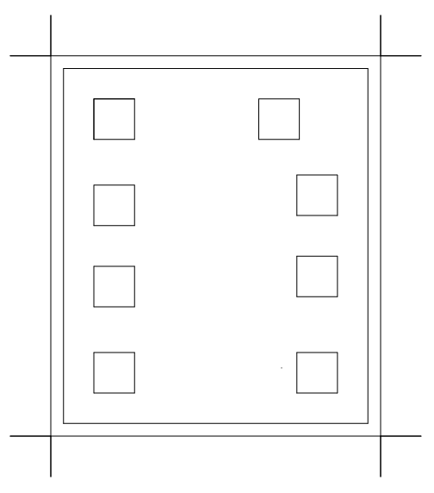
0.65mm

VDD2
VDD

y
OUT
X1
0.75mm
x
OUTN
X2

VSS
CE

Scribe line center

7-2 Flip Type
0.65mm

VSS
CE

y
OUT
X1
0.75mm
x
VDD2
X2

VDD
OUTN

Scribe line center

- IC Part # Identification
IC Identification Code (Option)
Fuse □□
Code 9 10
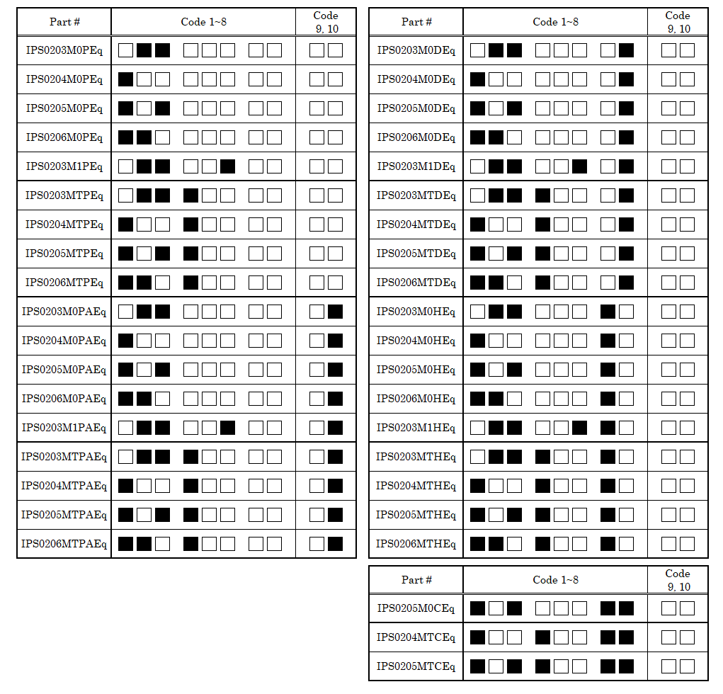
□ : Fuse no cut ■ : Fuse cut
IC Identification Code
Fuse □□□ □□□ □□
Code 1 2 3 4 5 6 7 8
LOGO : IPS0208_M_F (Flip type)
IPS0208M_S3 (Straight type of pCML)
IPS020_M_S3 (Others)

- Revision History

Revision No. | Revision  Date | Revised items | Contents
Revision No. | Revision  Date | Revised items | Before Revision | After Revision
SD-2.3 | 2025/11/04 | Wafer thickness 100um | Listed | As requested
SD-2.3 | 2025/11/04 | IPS0203M1PES | Under Development | Listed
SD-2.3 | 2025/11/04 | IPS0204M0HEF | Unlisted | Listed
SD-2.3 | 2025/11/04 | IPS0205M0HEF | Unlisted | Listed
SD-2.3 | 2025/11/04 | IPS0203M1HES | Under Development | Listed
SD-2.3 | 2025/11/04 | I_{DDD} Condition | CE≦0.3V | CE=GND

